**GoKart Lap Timing System Installation Guide and Technical Specification**

**Introduction**

This document discuss about the Gokart Lap Timing system and technical specifications and installation guidelines.

Kart Timer system is designed to use in kart tracks. The system can identify up to 250 different karts and measure their lap time with one millisecond accuracy.

The Kart Timing system is equipped to be used with Infrared beacon based Race tracks and Magnetic strip based tracks.

# System components

## Required components

* + 1. Computer with timing software
    2. Stationary Infrared Beacon
    3. Magnets
    4. Receiver module with WifI or Ethernet connectivity (off Kart controll station)
    5. Transmitter modules (in kart control station)
    6. IR Sensor
    7. Magnetic Strip Sensor
  1. **Optional Components**
     1. Camera Module for Receiver

The IR and Magnetic sensors a detachable from the transmitter (in kart control station) and are provided with 1.5m long flexible cables for providing flexibility of sensor positioning in the kart.

The in kart control station is powered with 6 AA batteries (not supplied), which should last long enough in ideal use cases, however is replaceable by the user. The kart control center is equipped with two power switches, which enables to turn off the module completely or turn off the magnetic sensor alone to reduce power consumption and to provide longer battery life. The in kart control center is also equipped with a battery monitor. So the Admin is informed with battery level of the transmitter.

The Receiver (off kart control center) and the IR beacon needs to be placed off track in the suitable positions as shown in fig-2. The Receiver and IR beacon are powered with regular micro-USB based power adapters (not supplied).

The receiver module is the main control center, which receives the lap time information from the karts and consolidates and provides the necessary information for the computer software.

The in kart transmitter and receiver uses a 2.4 GHz RF radio communication method for exchanging data. The transmitter provides detection data to the receiver along with a kart-id of the transmitter. The id could be programmed in the in kart transmitter module. Up to 255 unique IDs could be programmed on the transmitter, making it usable with 255 karts running together.

The receiver is also provided with an option to use a camera module, to enable automatically taking photos of the karts while completing the lap and the photos if enabled would be displayed on the scorecard software.

The receiver must be connected to the computer through the WiFi or using the Ethernet cables with the ports provided. Ethernet is preferred, as it does not require additional configuration of the receiver module.

1. **Installation directions**

The fig-1 below shows the block diagrom of the lap-timing system with all the components connected.

Power

Computer

IR Beacon

Reciever

IR

Radio

Magnetic Strip

Transmitter

Magnetic Sensor

IR Sensor

Fig-1

IR LEDs

Magnetic strip

IR Beacon

Receiver

to power Adaptor

track

To Computer

Fig-2

Fig-2 Above shows the Installation of IR Beacon and Recievers off track.

## Magnetic strip installation

One magnetic strip should be installed into the track.

### Magnetic strip installation using 150x19x10 ferrite magnets

* Cut a 20x20 mm groove across the track
* Lay a 20mm wide steel sheet along the groove
* Lay the magnets on the steel sheet. Rotate the magnets until the red side is visible of every magnet in the strip.
* WARNING! The magnets shall be laid with homogeneous polarization! It means, that only one pole of the magnets are visible from upwards. The north pole of our magnets are marked with red painting. The strip will be homogeneous, if the red side is visible of every magnet after the installation.
* The magnets are pushing each other with homogeneous polarization, but the steel sheet can join them. Duct tape can be used instead of steel sheet also.
* Check the polarization of the strip. It is homogeneous, if the red side is visible of every magnet. You can check the polarization with a piece of magnet also. Hold the magnet in you hand, and move it along the strip. If the polarization is homogeneous, the magnet in you hand does not rotate.

Next picture shows the WRONG magnetic strip installation (side view). The South (blue) and North (red) poles are pulling each other. The installation is easy, but the resultant magnetic field is inhomogeneous! It results in magnetic field degradation, and loss of  timing system reliability.

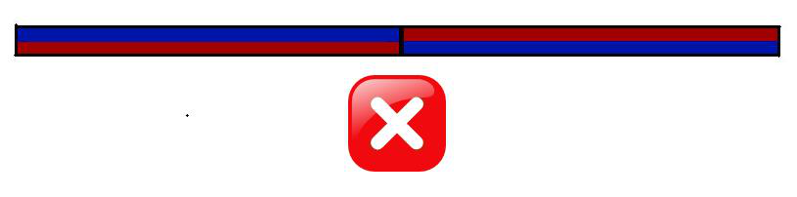

Next picture shows the GOOD magnetic strip installation. The South (blue) poles and the North (red) poles are pushing each other. The installation is not easy; the steel sheet under the magnets (grey) helps the installation greatly. Steel sheet can be used on the top of the strip also, without magnetic field degradation. The resultant magnetic field is homogeneous.

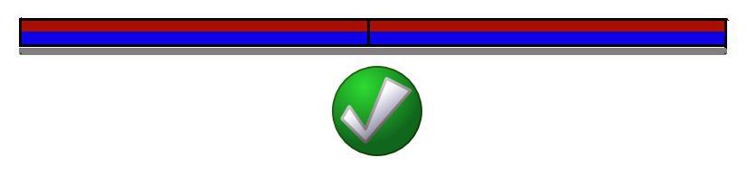

## Receiver module installation

* Fix the receiver module next to the magnetic strip, 3 meters above ground. The receiver should be maximum 8 meters from any point of the magnetic strip.
* Connect the receiver module with the computer using the ethernet cable/wifi dongle.
* Connect the reciever module to the appropriate micro-usb power adaptor

## Transmitter installation

* Drill installation holes on the floor of each kart. Be careful when choosing the place of the transmitter.
* Fix the transmitter on the floor of each kart.
* Drill holes for fixing the magnetic and IR sensors.
* Magnetic sensors should be placed such a way that it is at maximum 6cm height from the magnetic strip
* IR sensors should be placed with sensor facing straight up towards the IR beacon installed.
* Connect the sensor cables to the transmitter modules.

Care should be taken to connect each sensor only at their dedicated port.

## Software installation

TBD: TODO:

# Stability and reliability

The lap timing system is a stable and reliable system when correctly installed. It means that every lap of every running kart shall be identified, and the lap time accuracy shall be 1 millisecond. If you are experiencing problems with system stability and reliability, please check the following list.

## Magnetic strip recognition

Ensure that your magnetic strip is correctly installed. Check the homogeneity of the magnetic field. If you are using magnetic strip from other supplier, check if the magnets are strong enough.

Ensure that the distance between the transmitter and the magnetic strip is no more than 6 cm when passing the magnetic strip. Be careful with kerbs if your strip is not in straight, since it can lift up the kart.

Ensure that the kart speed is between 5 and 100 km/h when passing the magnetic strip

Ensure that no disturbing magnetic fields (e.g. engine) are in 50 cm distance of the transmitter. Be careful with the engine of the other karts, it can be a problem during close races.

## Radio transmit

Ensure that the distance between transmitter and receiver is no more than 8 m when passing the magnetic strip.

Ensure that no disturbing objects are between transmitter and receiver when passing the magnetic strip.

Ensure that the receiver is at least 2 m above ground. The optimal position is 3 m above magnetic strip, in center position.

## Computer and communication

Do not use longer cables than 100 m between receiver and computer.